Political Advertising and Socioeconomic Characteristics
An Analysis of Google Political Ad Spending Across U.S. States, 2020 to 2024
ISM4930 Final Project Report
Team Member: Quan Tran, Ha Tran, Quang Nguyen, Kimsing Lor, Yusuke Yoshizawa

1. Introduction
Over the past several years, digital platforms have become a major way for political campaigns to reach voters. Platforms like Google allow campaigns to target specific states and regions, which makes it easier to focus on spending where it matters most electorally. Google's advertising network covers Google Search, YouTube, and Display and Video 360, and has become one of the most widely used channels for political ads during U.S. federal elections.
One of the reasons why the United States is unique is that the country operates under the Electoral College system. Since campaigns will have to capture each state fully as opposed to simply winning the national popular vote, campaigns have a powerful incentive to spend their resources on swing states rather than distribute the money equally in all 50 states. From 2020 to 2024, there has been an observable change in the political landscape where Republican states increased from 25 to 31, whereas Democratic states declined from 26 to 20.
To investigate these patterns, we used information from the Google Political Ads Transparency Report in combination with information from the United States Census Bureau related to demographic and socioeconomic data. The two research questions for our analysis are:
- Does political advertising spending on Google vary systematically across U.S. states, and how did these patterns change between the 2020 and 2024 election cycles?
- Are states with lower median household income targeted with higher political advertising spending?
By combining information regarding political advertisement spending and the socioeconomic situation of individual states, we aimed at identifying both whether specific states received more attention and if campaigns favored certain states in terms of their economic standing.

2. Methodology
2.1 Data Sources
Three main data sets have been utilized for this research, all three of which are available online.
- Google Political Ads Transparency Report
Google Political Ads Transparency Report consists of information about all the verified political advertisers who posted their ads during elections using any platform from Google. Along with the details of the ad itself, such as advertiser name and ID, and the state it was targeting, the data set gives information about the amount spent a week, in a minimum and maximum USD range. The weekly spending helped us observe the changes from one week to another during election periods.
URL: https://console.cloud.google.com/marketplace/product/transparency-report/google-political-ads?project=wise-bongo-488321-j1
- U.S. Census Bureau American Community Survey
Data related to median income, poverty, percent of adult residents with bachelor's degree and above, and voter age were gathered through the American Community Survey conducted by the U.S. Census Bureau.
URL: https://data.census.gov
3. Political Leaning by Election Year
It was another small supplementary data source from Wikipedia, wherein the political party that won in each state for elections held in 2020 and 2024 were recorded. These were used to color-code the states as Democratic or Republican in all our maps.
URL: https://en.wikipedia.org/wiki/List_of_United_States_presidential_election_results_by_state
2.2 Data Preparation
In Tableau, we built a data source called Ads_final that links three tables together. The political_leaning_by_election_year.csv file is joined to the master socioeconomic table, which is then joined to Ads_final.csv. This setup allowed us to create visualizations that pull from both the advertising data and the Census data at the same time, which was important for socioeconomic analysis.
Because the Google dataset reports spending a range rather than an exact number, we used the average ad spend by state (Avg. Ad Spend by State) as our main spending metric throughout the workbook. In some views we also calculated a per-state average midpoint spend using the formula [(Spend Range Max + Spend Range Min) / 2] / Number of States. All spending figures in the analysis below refer to the average spend range max unless otherwise noted.

3. Analysis
3.1 The Shifting Electoral Map: 2020 to 2024
States were almost equally divided into Republicans and Democrats in 2020, with 26 states voting for the former and 25 states voting for the latter. This changed dramatically by 2024 when 31 states went to the Republicans and only 20 voted Democrat. Naturally, campaigns target their effort on swinging states, providing an explanation as to why funds were allocated in a particular way.
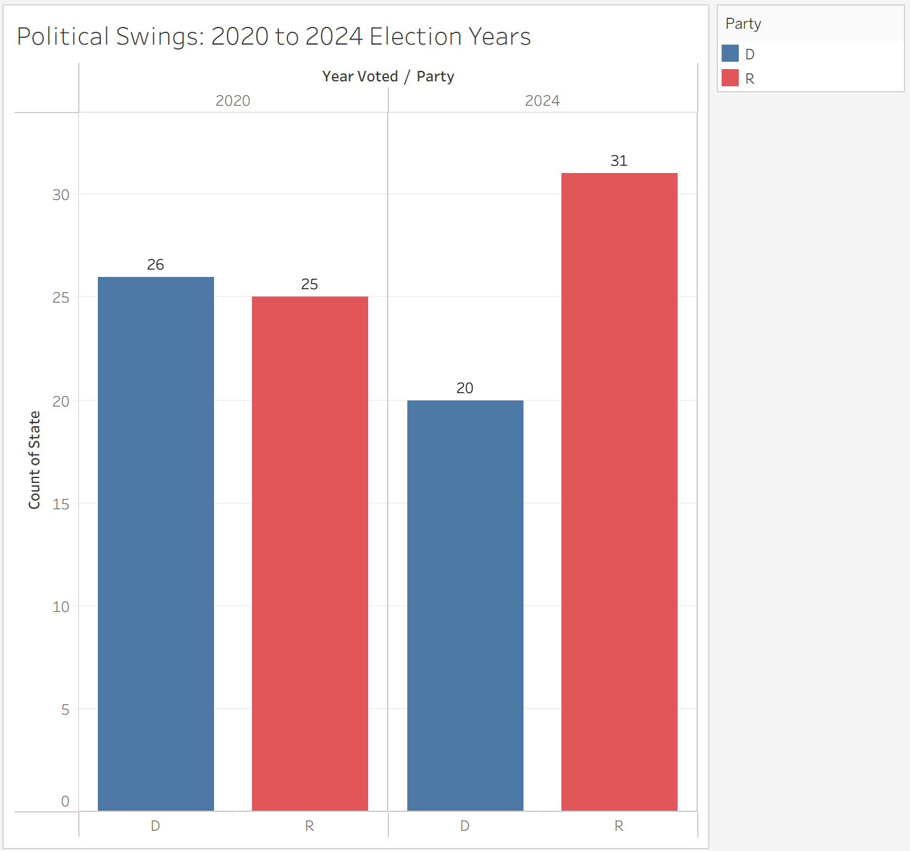
Figure: Political Swings: 2020 to 2024 Election Years

3.2 Where the Money Goes: Geographic Concentration of Ad Spending
The states which are colored in the Total Spending Heatmap are mainly those which are in the Midwest and Southeast parts of America, such as Montana, Michigan, Pennsylvania, and Georgia. Most states are colored very lightly on this map because they do not show much, if any, advertising at all. It should be noted that the map presented on the left includes all states in relation to their spending per capita while the one on the right only includes the seven swing states.
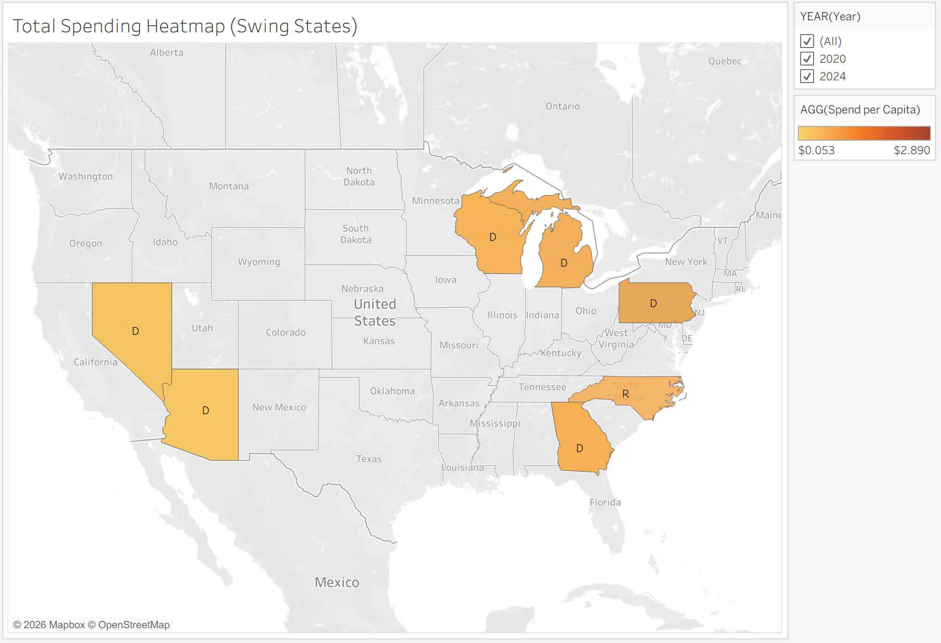Figure: Total Spending Heatmap by Swing States
The Ad Spending per Capita per State horizontal bar graph ranks all states based on ad spending per capita, which takes into consideration both election cycles. Pennsylvania tops the chart at about $1.65 per capita, with Michigan coming second at roughly $1.20, and Wisconsin third at approximately $0.95. Montana and Nevada rank fourth and fifth in this order at roughly $0.85 and $0.80 respectively, although it must be noted that these states have very low populations. Other states that rank below Pennsylvania include North Carolina, Iowa, and Georgia. Although states such as California, Texas, and New York may rank highly in terms of absolute spending, they have low rankings when population size is considered.
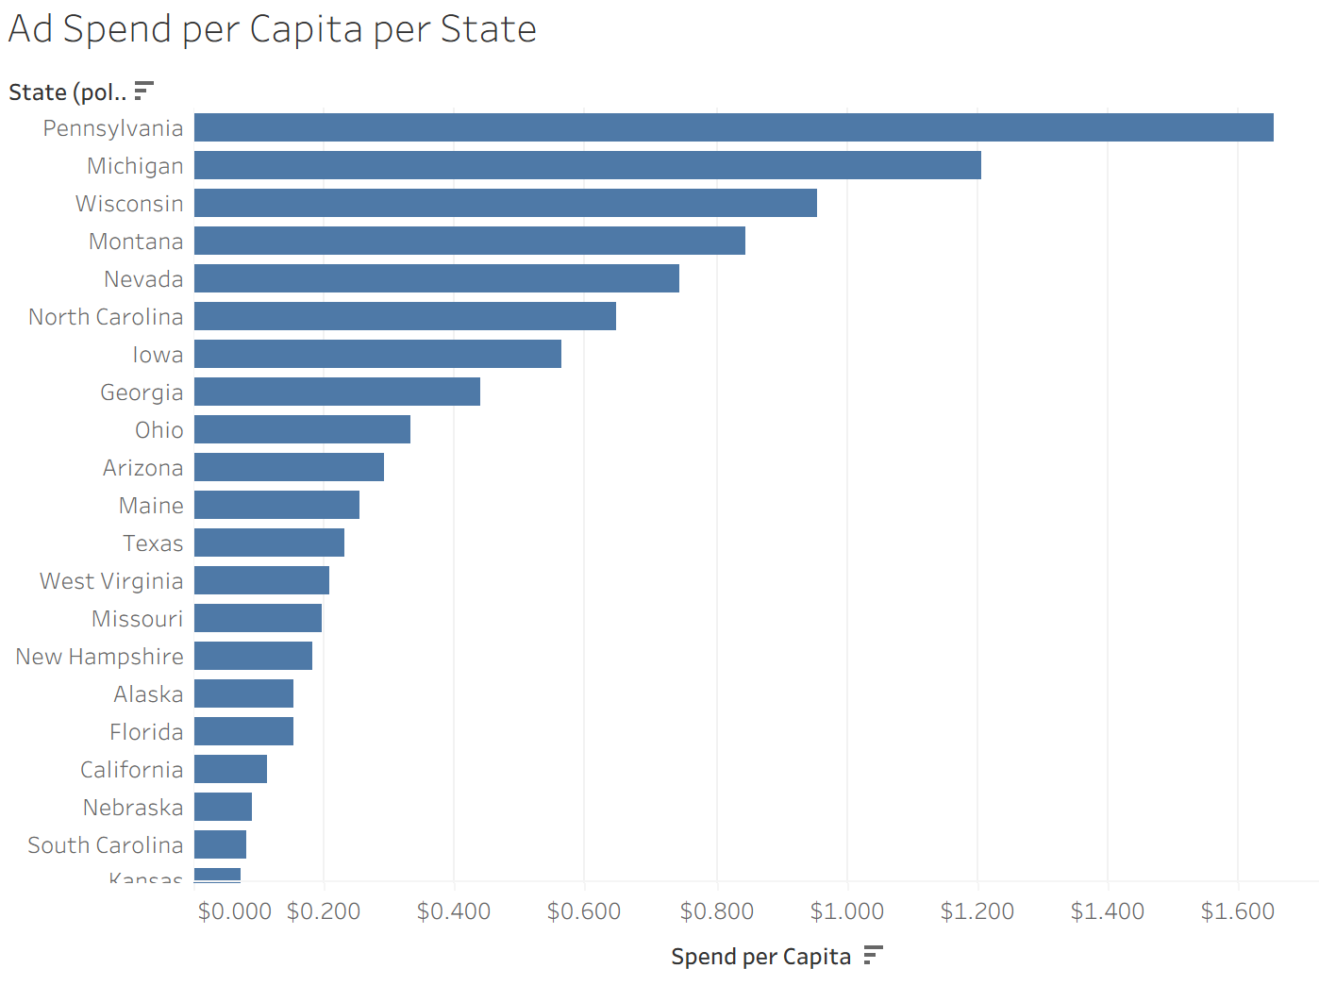
Figure: Ad Spend per Capita per State
3.3 Swing State Spending and Partisan Patterns
The expenditure in the six Democratic swing states in 2020 was between $159,194 in Nevada to $6,656,909 in Georgia, whereas North Carolina which went for the Republicans that year had an expenditure of $4,817,053.
However, by the next election in 2024, all the seven swing states went for the Republicans and there was a huge increase in expenditures. The seven swing states had the following amount spent on advertisement in millions: Pennsylvania with $37,795,548, Michigan $21,017,489, Wisconsin $9,383,351, North Carolina $9,077,503, Nevada $4,524,227, Arizona $2,930,060, and Georgia $2,850,946. All these seven states have been noted as the battlegrounds for the last few presidential elections (BBC, 2024: https://www.bbc.com/news/articles/c511pyn3xw3o).
When considering the expenditure per 100 voter-age population, Pennsylvania again tops the list at $2.94 per capita. This shows that even though the expenditure was high, it was not only large in number but also very intensive in targeting voters. Michigan again comes second at around $2 per capita, and Wisconsin and Nevada follow at roughly $1.50. When normalized by population, the states with the largest increases in advertising were the same ones that changed party outcomes, though the data alone cannot establish a causal relationship.
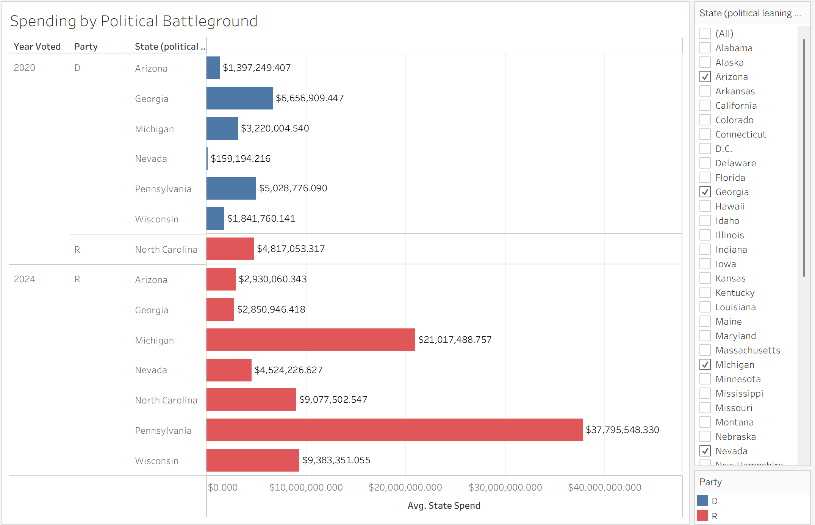Figure: Spending by Political Battleground
3.4 Does Income Predict Targeting? Median Income vs. Ad Spend
When expenditure is adjusted for population, the scatter plot of median income against spend per capita becomes more informative than using absolute values. In 2020, all states show very close to no spending per capita regardless of their level of income. By 2024, Pennsylvania was the state with the highest per capita spend at just over $3. Michigan follows it in second place at $2, and Wisconsin and Nevada with around $1.50 to $1.60 per capita. Most importantly, those states have the highest per capita expenditure because they have their median income ranging from $70,000 to $80,000 – which is above the national median. The low-income states, like Mississippi and West Virginia, received virtually nothing in spending per capita each year. There is nothing in the analysis to suggest that candidates' campaigns target states with low-income people.
If we look at the swing-states only, the finding would be similar. All seven states are expected to have median income in the range from $65,000 to $82,000, with Pennsylvania and Michigan receiving the highest expenditure, not the poorest states within the pool.
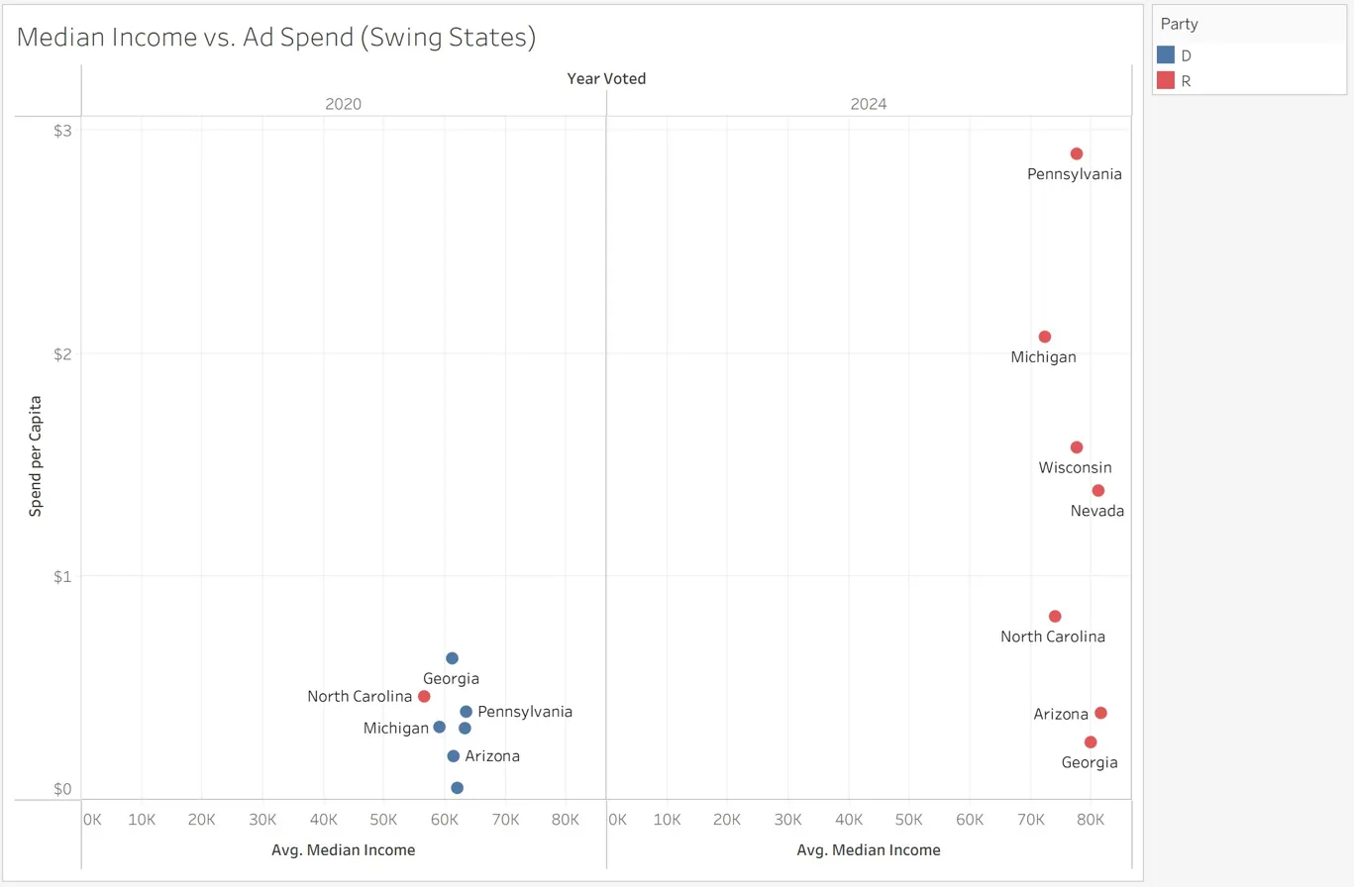
Figure: Median Income vs. Ad Spend
3.5 Relative vs. Absolute Spending: Does Normalization Change the Picture?
The chart Relative vs. Absolute Ad Spend per State shows a comparison of spend per capita and state absolute spending. In terms of absolute state ad budget, Pennsylvania stands out way ahead followed by Michigan, then comes to Wisconsin, North Carolina, and Texas. But the relative figures paint a different picture when we look at spending per capita. Again, Pennsylvania takes the top position, at about $3 per capita, and Michigan comes second at about $2. But Wisconsin ranks high compared to its state spend, and Nevada follows it up.
Similarly, Montana and West Virginia have relatively high per-capita figures compared to low absolute figures, implying that the campaigns were focusing on these states more aggressively even without having much budget. States like California, New York, and Texas may seem to be targeted aggressively due to their large absolute budgets; however, this is not the case, as they rank quite poorly in the per-capita category due to huge population numbers.
Hence, normalization by the population helps us in getting a clearer picture. We find that the competitive battleground states are equally aggressive regardless of whether we normalize spending data by the population or not.
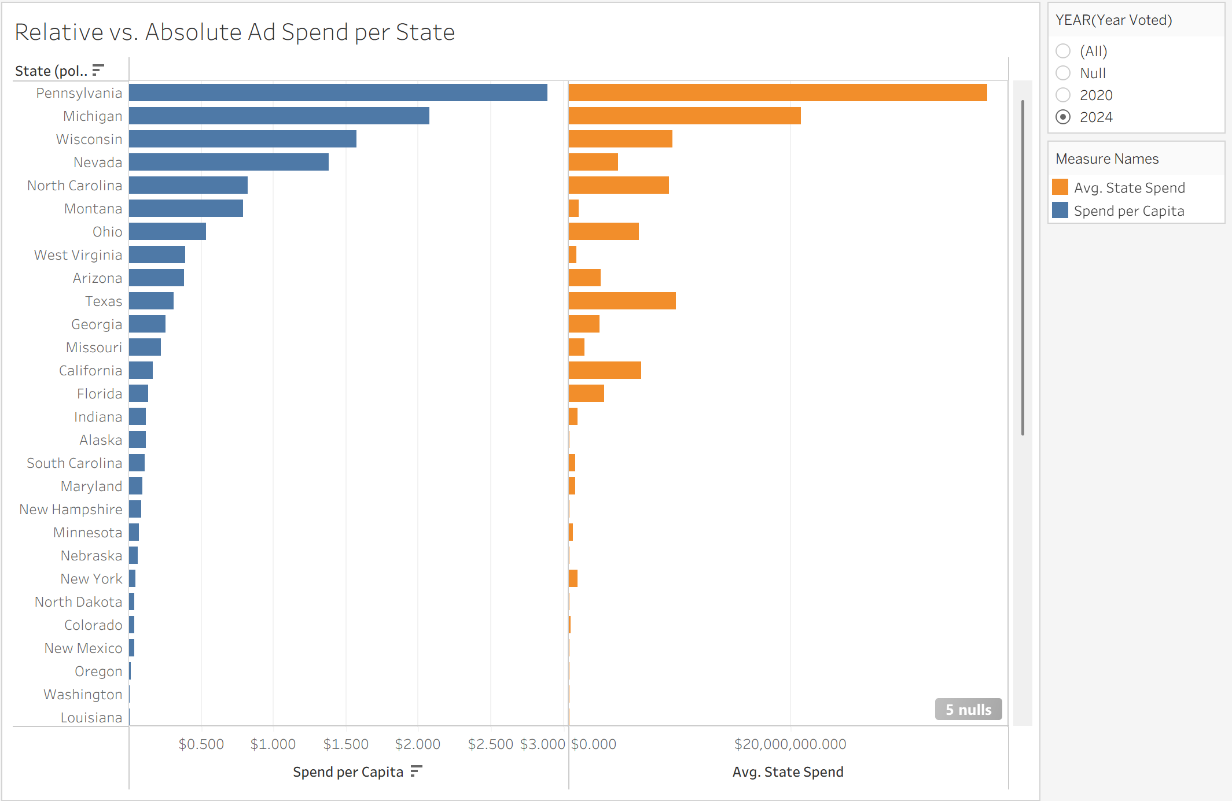Figure: Relative vs. Absolute Ad Spend per State
3.6 Ad Spending and Educational Attainment
The states that show the lowest spend per capita, regardless of education level, include all the states in 2020. The exception for this observation comes with Iowa and Montana, showing slightly above $1 per capita. There is no apparent relationship between the two variables in 2020.
States with the highest spend per capita in 2024 range over a short interval of educational attainment. The first state to be ranked is Pennsylvania with the highest spend of nearly $3 per capita, having about 33% bachelor's degree holders, followed by Michigan at about $2 per capita, and the percentage of bachelor's degree holders ranging at 30%. Other high-spending states include Wisconsin and Nevada with almost $1.50 per capita in a similar proportion, ranging from 30 to 32%. The states with higher education levels, such as Colorado at 48% and California with about 45%, recorded near-zero spend per capita.
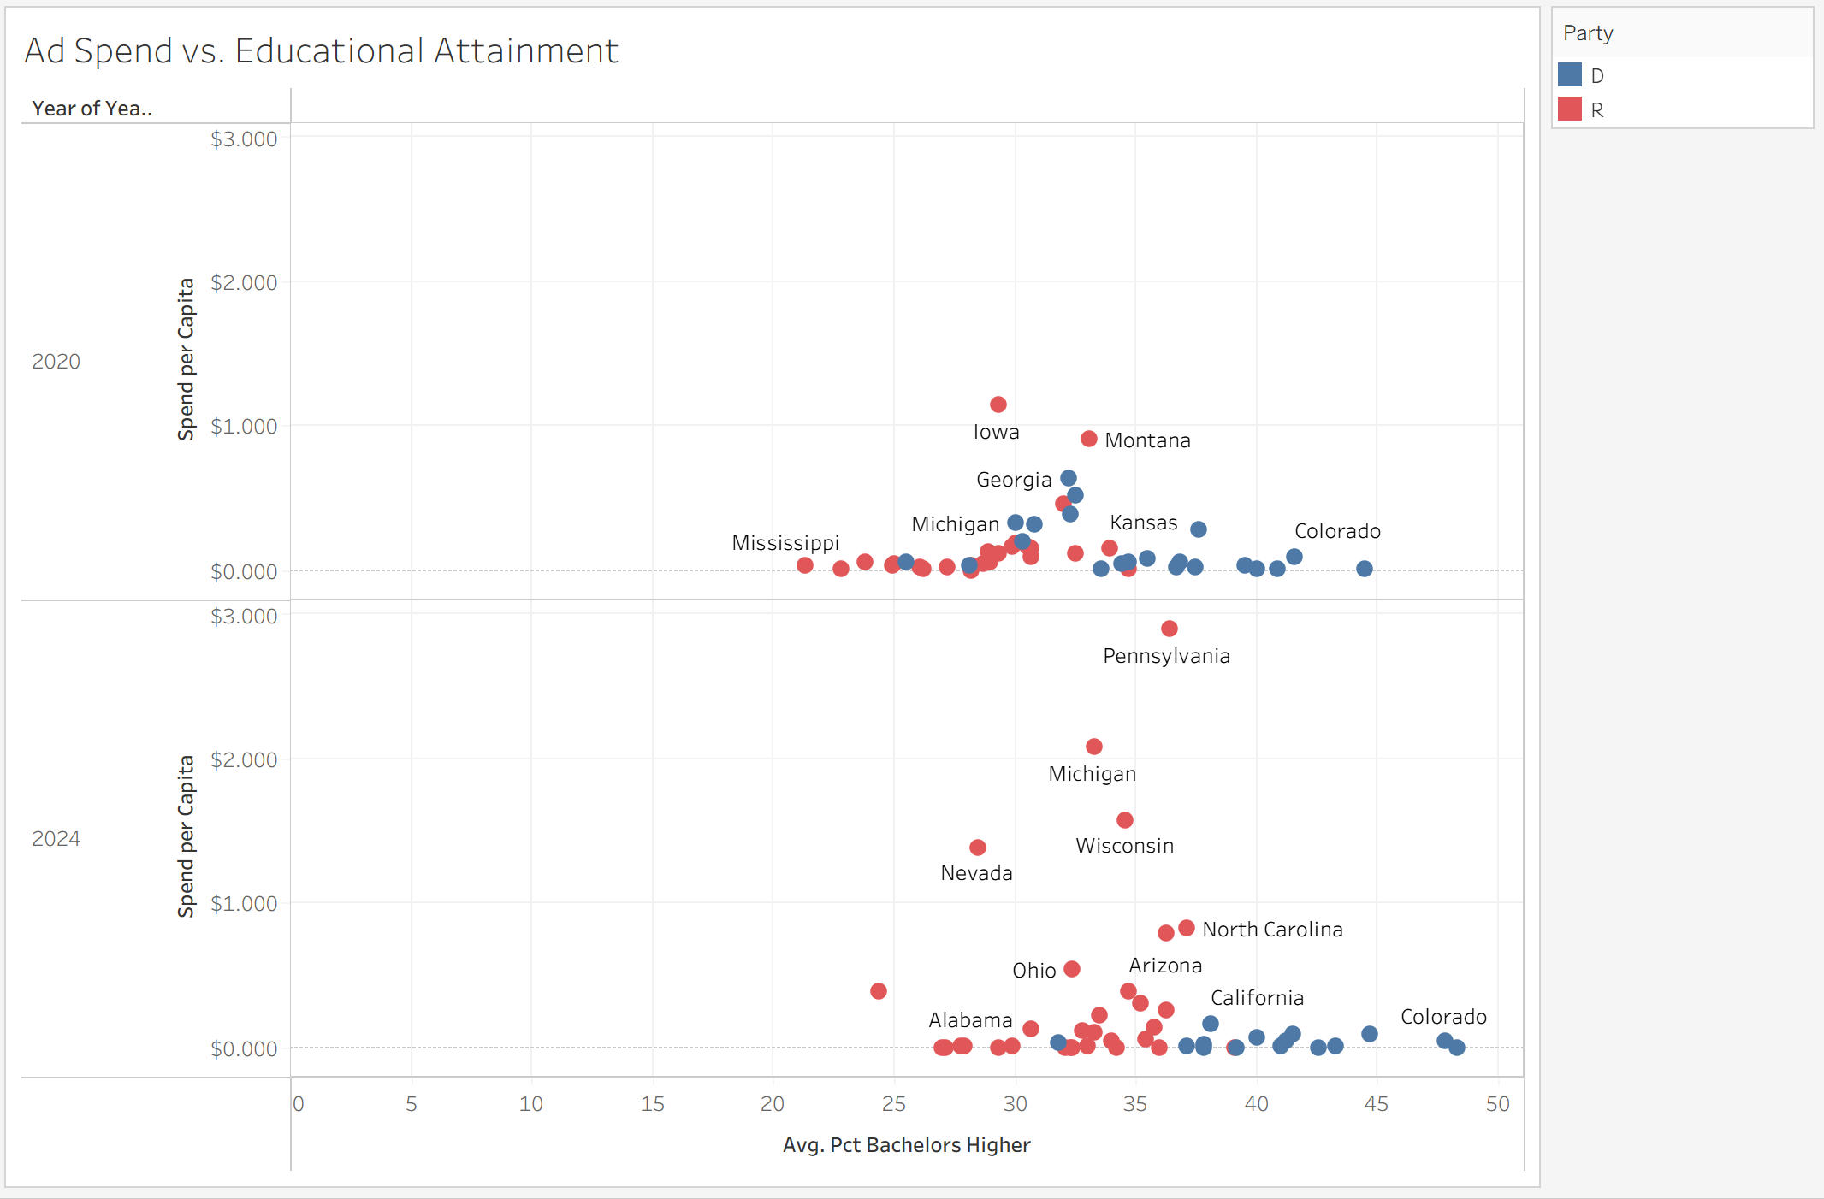Figure: Ad Spend vs. Educational Attainment
This trend becomes much more evident when the data is reduced to the seven swing states only. For the year 2020, all seven swing states had a similar trend of low spending per capita, and there was no correlation between education level and spending. In the year 2024, all the seven swing states turned Republican, and the spending became high, with Pennsylvania spending about $3 per capita, Michigan $2, and Wisconsin and Nevada $1.40-$1.60. Notably, all seven states have a similar education level, ranging between 25% and 37%, but their spending amounts differ.
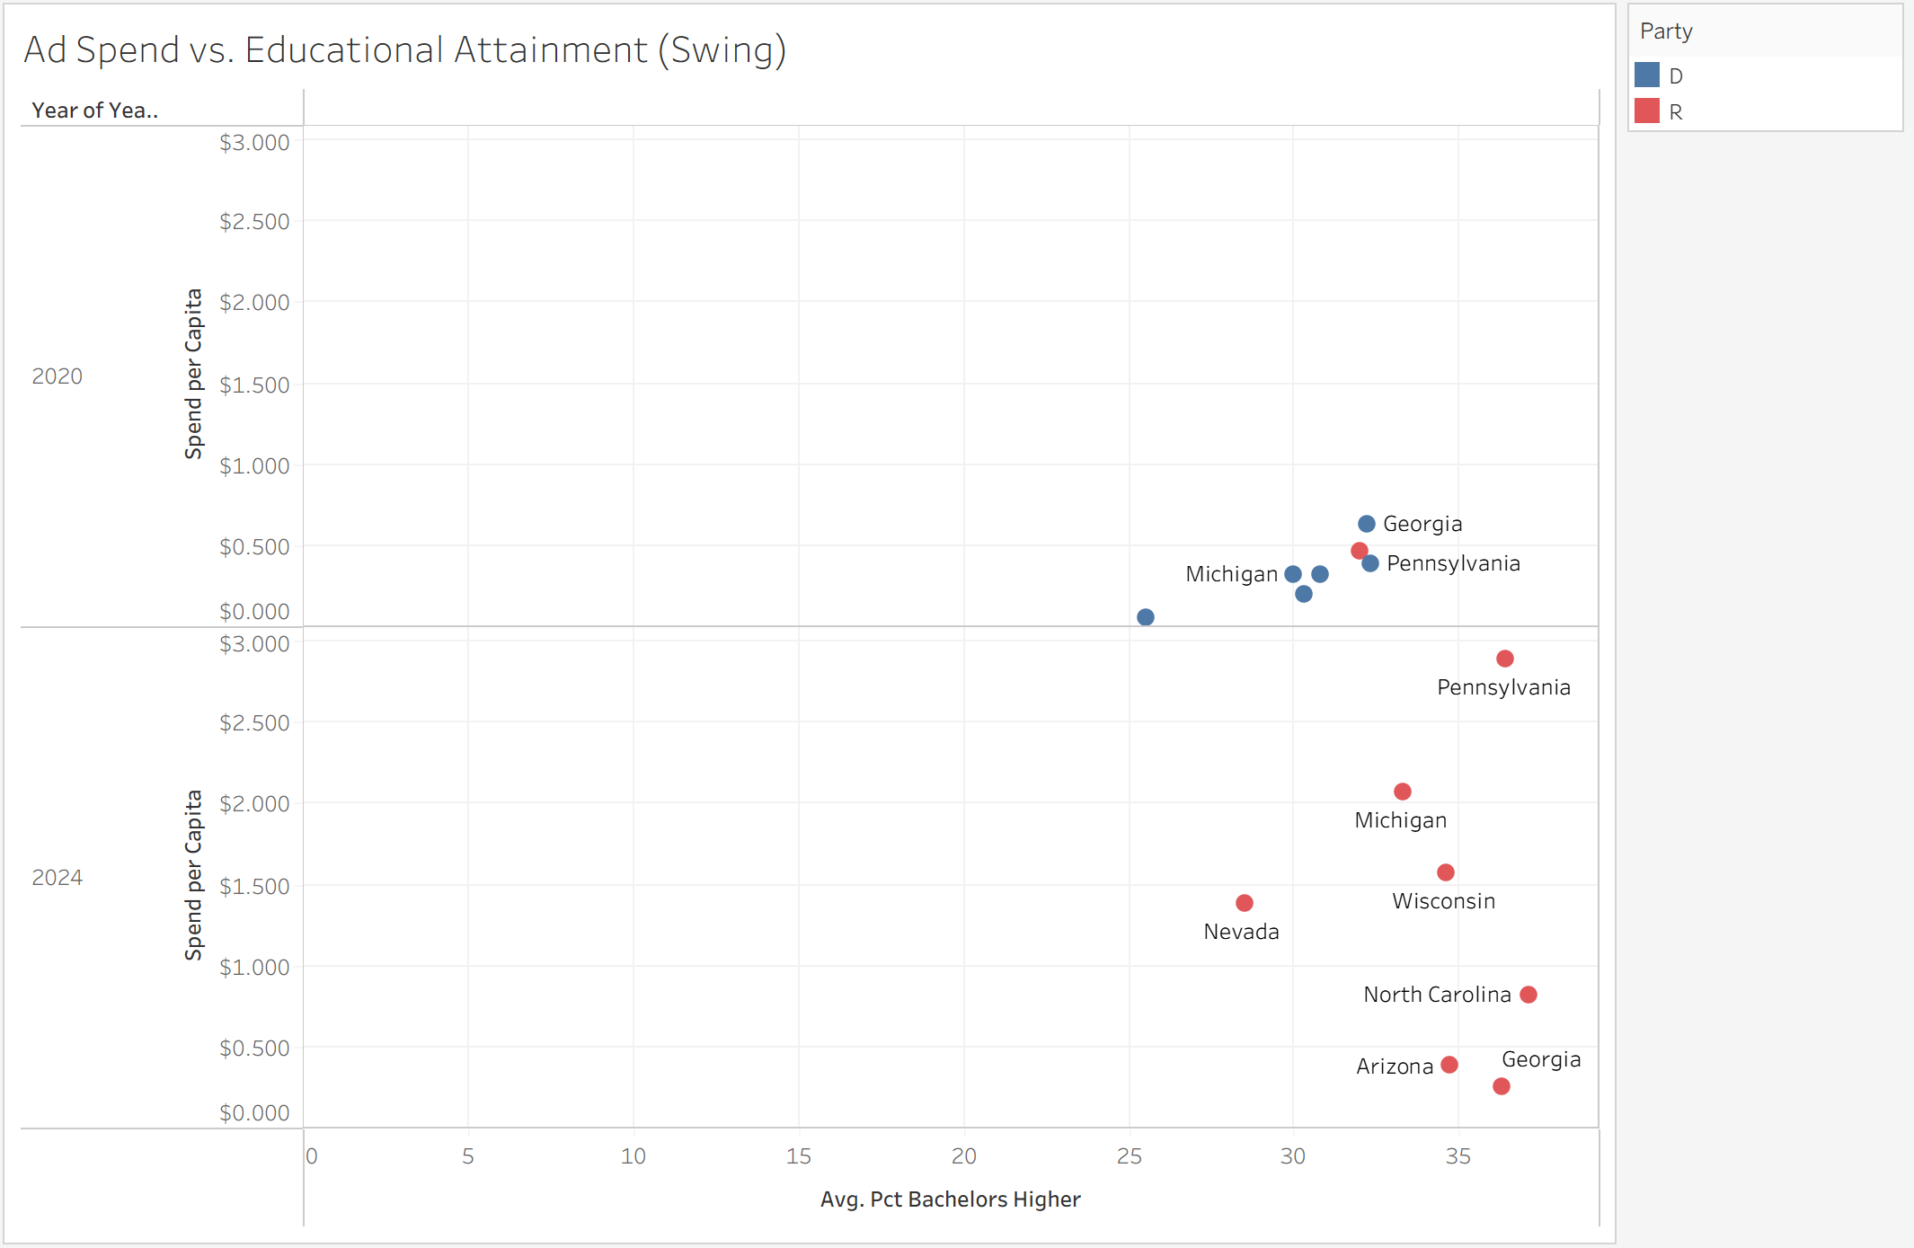
Figure: Ad Spend vs. Educational Attainment (Swing States)
3.7 Poverty Rate and Impression Reach
The poverty rate in states that received advertising remained consistent between 10% and 13% in both elections without deviation, indicating that campaigns are not targeting higher poverty areas by increasing advertising expenditure.
The Socioeconomic Scatter places educational attainment on the horizontal axis, poverty rate on the vertical one, and spend per capita in bubbles. All bubbles are small and evenly distributed across the chart in 2020, indicating that no combination of poverty rate and education level has received disproportionately high amounts of advertising investment. Despite being some of the poorest states in the country, Mississippi, Kentucky, and West Virginia have bubbles of equal size each year even as high poverty areas.
In 2024, bubbles are bigger and clustered around areas of 30 to 40 percent educational attainment, which corresponds to 10 to 13 percent poverty rate, being the average for both categories. States falling within extreme categories in either educational attainment or poverty rate did not receive much advertising.
In the bar graph of Ad Spend Over Time in the dashboard, Pennsylvania is ahead at $1.65 per person, followed by Michigan and Wisconsin at $1.20 and $0.95, respectively. All three are competitive states, neither the poorest nor least educated.
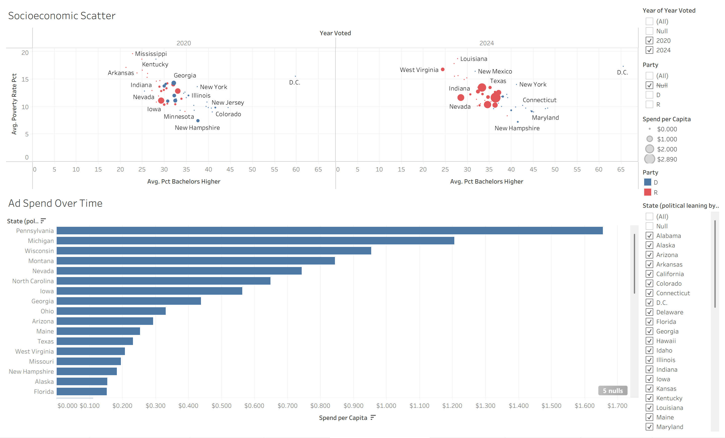Figure: Socioeconomic Scatter and Ad Spend Over Time (Dashboard)
3.8 Ad Spend and Voter-Age Population
In 2020, there was very little spending by campaigns in all the swing states, regardless of whether the swing state had a smaller or larger population size, since the trend lines for both Republicans and Democrats remained stagnant and close to zero. However, in 2024, there is an upward shift in the Republican trend line, implying that Republican-leaning swing states received much more advertising per capita than in 2020.
Arizona is the highest spender of approximately $19,000 maximum spend range even though its voter-age population size is small, at 5 million people. Following Arizona is North Carolina, which spends an average of approximately $17,000 even though it has a similar voter-age population size. Even though Georgia has a higher voter-age population size of 8 million, it received only $14,500 worth of advertising. Similarly, Pennsylvania and Michigan are the two largest states in terms of voter-age population size, at 9 to 11 million people. The two states, however, received approximately $11,000 and $10,000, respectively.
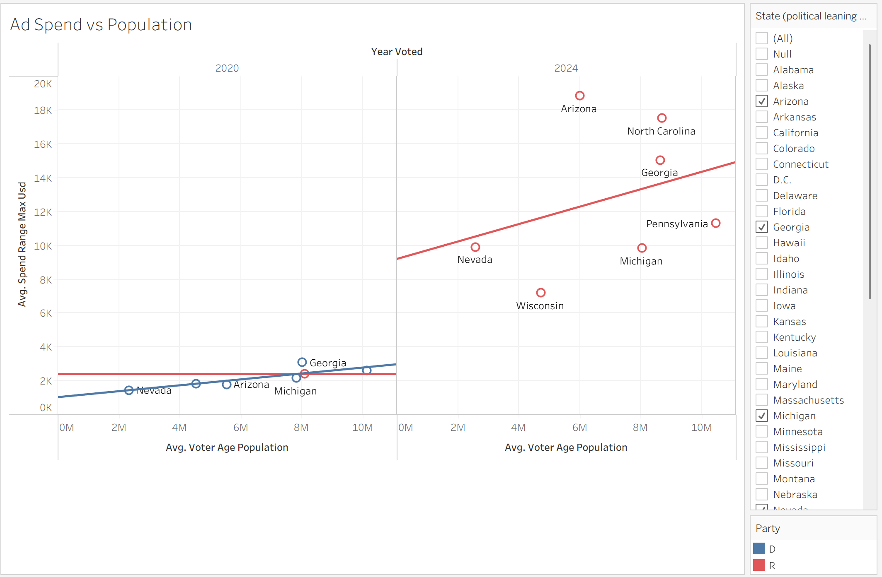Figure: Ad Spend vs Population
3.9 Income Trends in Swing States Over Time
The animation Median Income in Swing States 2023 demonstrates the changes that occurred in terms of median household income in the seven swing states during the years 2020 to 2024. In all seven states, we see an increase in income over the three years. In 2023, most of the states were converging at levels ranging between $65,000 and $76,000, while Arkansas was at the lower level of $59,000 and Michigan and North Carolina were at the high end near $76,000. This visualization has taken input data from both the Census and the political leaning table.
The growing trend in terms of income in the swing states proves our finding that these states are not economically disadvantaged states. They are middle income states and serve as the targets of advertisements based on their competitiveness in elections.
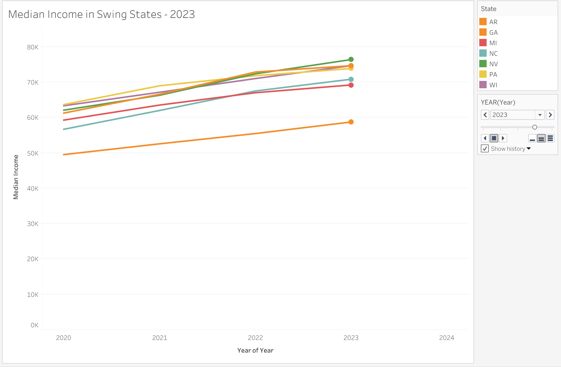Figure: Median Income in Swing States 2023 (Dashboard animated line chart)
4. Conclusion
4.1 Summary of Findings
The use of the Google political ads dataset in combination with the U.S. Census socioeconomic dataset allowed answering two research questions related to the distribution of political ad expenditure among U.S. states.
The first research question is apparent from the data analysis that there were significant disparities in expenditures among states and that such disparities expanded greatly between 2020 and 2024. Political ads were highly concentrated in relatively few competitive states. After normalization per capita, the same states remained on top of the list, with Pennsylvania having spent close to $3 per person, Michigan second at almost $2, and Wisconsin and Nevada third and fourth at roughly $1.50. The rest of the states had received minimal to zero spending from both years. All seven historical competitive states turned Republican in 2024 and experienced considerable spending increases from 2020.
For the second research question, the data do not support the idea that lower-income states are more heavily targeted. The scatter plots comparing spend per capita against median income, poverty rate, and educational attainment consistently show that socioeconomic characteristics are not strong predictors of advertising intensity. The highest-spending states are moderate-income battleground states, and electoral competitiveness is the main factor driving where campaigns choose to spend their money.
4.2 Possible Explanations
There is reason for the focus of advertising on swing states when taking into consideration the function of the Electoral College system. Once a state is determined as having swung towards a particular candidate or party, further investment will be unproductive. The increase in ad spending between 2020 and 2024 could be explained by the increased use of digital advertising funds and competition in key states such as Pennsylvania and Michigan in 2024.
A lack of targeting according to income is also logical, considering that campaigns are seeking out persuasive voters in specific regions of the country rather than attempting to reach certain segments of the population based on income.
4.3 Directions for Future Research
Considering our results, some of the research questions worth pursuing in the future include:
- How consistent are these observations at the level of county and congressional districts? It may be that income inequality within swing states paints a different picture than the averages for individual states.
- How does Google's spending on political ads differ from Facebook, TV ads, and direct mailing among the same group of states? We should find out whether these three media have the same concentration in swing states or target different groups of people.
- Is there any link between increased expenditure on ads in a state and voting behavior such as voter turnout or voting margin after adjusting for the activity of other campaigns?
- Do the observed patterns repeat in midterm elections? Are ads evenly distributed when a presidential election is not at stake?
- With all the swing states becoming Republican in 2024, can advertising activity become a precursor of election results, or do advertisers only react to what polls indicate?
To answer the above questions, it would take more detailed geographic data, data on several elections, and most importantly, data on advertisements across multiple platforms instead of data only from Google.

